**Crude Oil Vs. Auto Industry**

**Project Summary**

**Questions and Major Findings:**

Does the price of oil affect auto industry sales?

* From looking at the graphs we saw that when oil prices increased, revenue for car companies increased. When oil prices decreased, car revenue decreased. Same phenomena occurred with stock prices.

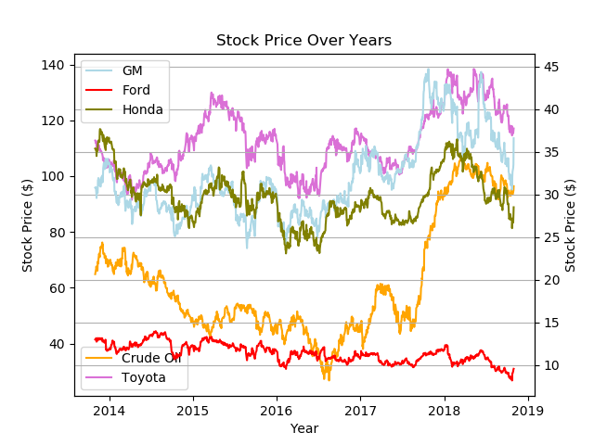

Is there a correlation between price of crude oil and the American auto industry?

* Our T-Test conclusions showed us evidence that there is a correlation between the price of crude oil and the American auto industry. Both the crude oil population and the specific car population were normally distributed across the mean and all p-values were less than the standard .05 indicating there is a correlation. Below is an example of the Honda T-Test.

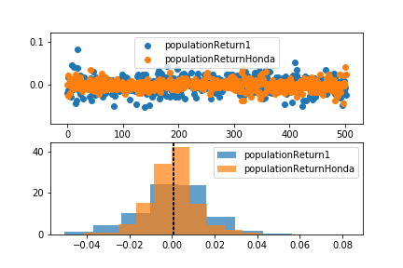

Will stock prices and overall cost of crude oil have an inverse effect on the Auto Industry? For an example will auto sales decrease as oil prices increase and vice versa.

* We expected an inverse correlation, but instead there was a direct correlation. We don’t know if there is a direct causation for this or if crude oil prices have a major impact on the economy as whole which causes this correlation. Further research would need to be conducted on how other items are impacted by fluctuations in crude oil stock prices.

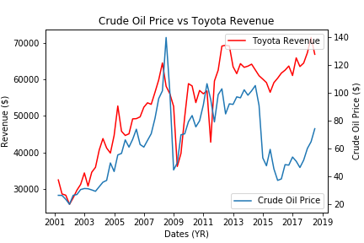

Does this affect vary from auto company to auto company?

* Ford auto company differed from the rest of the car companies we tested (Honda, Toyota, and GM) because at times you can see an inverse relationship where gas prices decline and Ford’s revenue increases. We believe this difference is possibly due to Ford making larger vehicles which tend to use gas more quickly than smaller vehicles. Further research would need to be done on larger vehicle companies to see if this holds true for all large vehicle manufacturing companies.

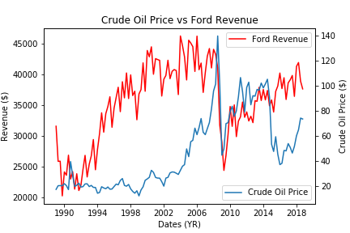

If we had two more weeks:

* We would like to explore the stock market in general. Is it just car sales that oil prices affect, or does oil affect our overall economy? If it’s just car sales, why do car sales increase as oil prices increase?